1.

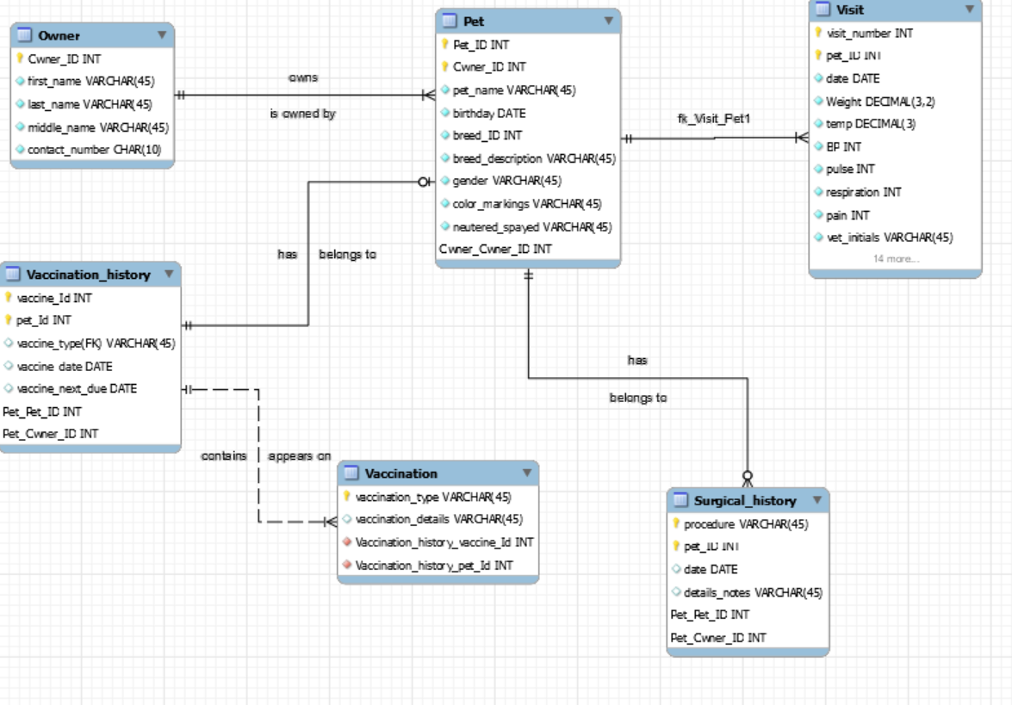

2.

-- MySQL Script generated by MySQL Workbench

-- Sun Feb 16 19:17:29 2020

-- Model: New Model Version: 1.0

-- MySQL Workbench Forward Engineering

SET @OLD_UNIQUE_CHECKS=@@UNIQUE_CHECKS, UNIQUE_CHECKS=0;

SET @OLD_FOREIGN_KEY_CHECKS=@@FOREIGN_KEY_CHECKS, FOREIGN_KEY_CHECKS=0;

SET @OLD_SQL_MODE=@@SQL_MODE, SQL_MODE='ONLY_FULL_GROUP_BY,STRICT_TRANS_TABLES,NO_ZERO_IN_DATE,NO_ZERO_DATE,ERROR_FOR_DIVISION_BY_ZERO,NO_ENGINE_SUBSTITUTION';

-- -----------------------------------------------------

-- Schema mydb

-- -----------------------------------------------------

-- -----------------------------------------------------

-- Schema mydb

-- -----------------------------------------------------

CREATE SCHEMA IF NOT EXISTS `mydb` DEFAULT CHARACTER SET utf8 ;

USE `mydb` ;

-- -----------------------------------------------------

-- Table `mydb`.`Owner`

-- -----------------------------------------------------

DROP TABLE IF EXISTS `mydb`.`Owner` ;

CREATE TABLE IF NOT EXISTS `mydb`.`Owner` (

`Owner_ID` INT NOT NULL AUTO_INCREMENT,

`first_name` VARCHAR(45) NOT NULL,

`last_name` VARCHAR(45) NOT NULL,

`middle_name` VARCHAR(45) NOT NULL,

`contact_number` CHAR(10) NOT NULL,

PRIMARY KEY (`Owner_ID`))

ENGINE = InnoDB;

-- -----------------------------------------------------

-- Table `mydb`.`Pet`

-- -----------------------------------------------------

DROP TABLE IF EXISTS `mydb`.`Pet` ;

CREATE TABLE IF NOT EXISTS `mydb`.`Pet` (

`Pet_ID` INT NOT NULL AUTO_INCREMENT,

`Owner_ID` INT NOT NULL,

`pet_name` VARCHAR(45) NOT NULL,

`birthday` DATE NOT NULL,

`breed_ID` INT NOT NULL,

`breed_description` VARCHAR(45) NOT NULL,

`gender` VARCHAR(45) NOT NULL,

`color_markings` VARCHAR(45) NOT NULL,

`neutered_spayed` VARCHAR(45) NOT NULL,

`Owner_Owner_ID` INT NOT NULL,

PRIMARY KEY (`Pet_ID`, `Owner_ID`, `Owner_Owner_ID`),

INDEX `fk_Pet_Owner1_idx` (`Owner_Owner_ID` ASC) VISIBLE,

CONSTRAINT `fk_Pet_Owner1`

FOREIGN KEY (`Owner_Owner_ID`)

REFERENCES `mydb`.`Owner` (`Owner_ID`)

ON DELETE NO ACTION

ON UPDATE NO ACTION)

ENGINE = InnoDB;

-- -----------------------------------------------------

-- Table `mydb`.`Visit`

-- -----------------------------------------------------

DROP TABLE IF EXISTS `mydb`.`Visit` ;

CREATE TABLE IF NOT EXISTS `mydb`.`Visit` (

`visit_number` INT NOT NULL AUTO_INCREMENT,

`pet_ID` INT NOT NULL,

`date` DATE NOT NULL,

`Weight` DECIMAL(3,2) NOT NULL,

`temp` DECIMAL(3) NOT NULL,

`BP` INT NOT NULL,

`pulse` INT NOT NULL,

`respiration` INT NOT NULL,

`pain` INT NOT NULL,

`vet_initials` VARCHAR(45) NOT NULL,

`fecal_exam_results` VARCHAR(45) NOT NULL,

`fecal_exam_notes` VARCHAR(45) NOT NULL,

`heartworm_test_results` VARCHAR(45) NOT NULL,

`heartworm_test_notes` VARCHAR(45) NOT NULL,

`allergy_name1` VARCHAR(45) NOT NULL,

`allergy_notes1` VARCHAR(45) NOT NULL,

`allergy_name2` VARCHAR(45) NOT NULL,

`allergy_notes2` VARCHAR(45) NOT NULL,

`time_spent_outside` DECIMAL NOT NULL,

`pet_diet` VARCHAR(45) NOT NULL,

`owner_signiture` VARCHAR(45) NOT NULL,

`date_signed` DATE NOT NULL,

`Pet_Pet_ID` INT NOT NULL,

`Pet_Owner_ID` INT NOT NULL,

PRIMARY KEY (`visit_number`, `pet_ID`, `Pet_Pet_ID`, `Pet_Owner_ID`),

INDEX `fk_Visit_Pet1_idx` (`Pet_Pet_ID` ASC, `Pet_Owner_ID` ASC) VISIBLE,

CONSTRAINT `fk_Visit_Pet1`

FOREIGN KEY (`Pet_Pet_ID` , `Pet_Owner_ID`)

REFERENCES `mydb`.`Pet` (`Pet_ID` , `Owner_ID`)

ON DELETE NO ACTION

ON UPDATE NO ACTION)

ENGINE = InnoDB;

-- -----------------------------------------------------

-- Table `mydb`.`Surgical_history`

-- -----------------------------------------------------

DROP TABLE IF EXISTS `mydb`.`Surgical_history` ;

CREATE TABLE IF NOT EXISTS `mydb`.`Surgical_history` (

`procedure` VARCHAR(45) NOT NULL,

`pet_ID` INT NOT NULL,

`date` DATE NULL,

`details_notes` VARCHAR(45) NULL,

`Pet_Pet_ID` INT NOT NULL,

`Pet_Owner_ID` INT NOT NULL,

PRIMARY KEY (`procedure`, `pet_ID`, `Pet_Pet_ID`, `Pet_Owner_ID`),

INDEX `fk_Surgical_history_Pet1_idx` (`Pet_Pet_ID` ASC, `Pet_Owner_ID` ASC) VISIBLE,

CONSTRAINT `fk_Surgical_history_Pet1`

FOREIGN KEY (`Pet_Pet_ID` , `Pet_Owner_ID`)

REFERENCES `mydb`.`Pet` (`Pet_ID` , `Owner_ID`)

ON DELETE NO ACTION

ON UPDATE NO ACTION)

ENGINE = InnoDB;

-- -----------------------------------------------------

-- Table `mydb`.`Vaccination_history`

-- -----------------------------------------------------

DROP TABLE IF EXISTS `mydb`.`Vaccination_history` ;

CREATE TABLE IF NOT EXISTS `mydb`.`Vaccination_history` (

`vaccine_Id` INT NOT NULL AUTO_INCREMENT,

`pet_Id` INT NOT NULL,

`vaccine_type(FK)` VARCHAR(45) NULL,

`vaccine_date` DATE NULL,

`vaccine_next_due` DATE NULL,

`Pet_Pet_ID` INT NULL,

`Pet_Owner_ID` INT NULL,

PRIMARY KEY (`vaccine_Id`, `pet_Id`, `Pet_Pet_ID`, `Pet_Owner_ID`),

INDEX `fk_Vaccination_history_Pet1_idx` (`Pet_Pet_ID` ASC, `Pet_Owner_ID` ASC) VISIBLE,

CONSTRAINT `fk_Vaccination_history_Pet1`

FOREIGN KEY (`Pet_Pet_ID` , `Pet_Owner_ID`)

REFERENCES `mydb`.`Pet` (`Pet_ID` , `Owner_ID`)

ON DELETE NO ACTION

ON UPDATE NO ACTION)

ENGINE = InnoDB;

-- -----------------------------------------------------

-- Table `mydb`.`Vaccination`

-- -----------------------------------------------------

DROP TABLE IF EXISTS `mydb`.`Vaccination` ;

CREATE TABLE IF NOT EXISTS `mydb`.`Vaccination` (

`vaccination_type` VARCHAR(45) NOT NULL,

`vaccination_details` VARCHAR(45) NULL,

`Vaccination_history_vaccine_Id` INT NOT NULL,

`Vaccination_history_pet_Id` INT NOT NULL,

PRIMARY KEY (`vaccination_type`),

INDEX `fk_Vaccination_Vaccination_history1_idx` (`Vaccination_history_vaccine_Id` ASC, `Vaccination_history_pet_Id` ASC) VISIBLE,

CONSTRAINT `fk_Vaccination_Vaccination_history1`

FOREIGN KEY (`Vaccination_history_vaccine_Id` , `Vaccination_history_pet_Id`)

REFERENCES `mydb`.`Vaccination_history` (`vaccine_Id` , `pet_Id`)

ON DELETE NO ACTION

ON UPDATE NO ACTION)

ENGINE = InnoDB;

SET SQL_MODE=@OLD_SQL_MODE;

SET FOREIGN_KEY_CHECKS=@OLD_FOREIGN_KEY_CHECKS;

SET UNIQUE_CHECKS=@OLD_UNIQUE_CHECKS;

3.

* I used auto incrementing for the surrogate keys that were a count of the number of visits
* I used surrogate keys of pet_ID for all of the columns to link them all to the pet and in turn the owner as well